What is a Network Operating System?
A network operating system is software that connects multiple devices and computers on the network and allows them to share resources on the network. It is designed to facilitate the efficient and secure exchange of data, manage network protocols, and provide centralized administration and control over network resources.

- Resource sharing of hardware devices, such as printers and scanners, and software resources, such as files and databases
- Seamless communication and data transfer between computers on the network, using network protocols such as TCP/IP
- Authenticate users and manage access controls to define and enforce permissions and restrictions on users' actions within the network

- Incorporates security measures to protect the network and its resources from unauthorized access, data breaches, and malicious attacks.
Common examples of network operating systems include Microsoft Windows Server, macOS Server, Unix, and Linux distributions like Ubuntu Server. In this module, we’ll focus on the Unix and Linux operating systems.

What is Unix?
UNIX was developed at Bell Labs by a group of programmers and was designed to be a portable, flexible, and powerful operating system for various types of computer hardware. It allows multiple processes to run simultaneously and features a command-line interface known as a shell. Users can interact with the operating system by entering commands. UNIX offers a programming environment that is rich and diverse, providing a wide range of programming languages and development tools, including the C programming language, which was initially developed on UNIX.

Finally, UNIX is also ideal for networked environments, thanks to its built-in support for networking. It contains communication tools and networking protocols that enable systems to communicate with one another.

Unix Architecture
The basic architecture of the UNIX system consists of the following components. Click each component name to learn more
Hardware
Kernel
Shell
Applications and Command Processes

Let’s take a look at some key features of this security model beginning with the root user.

Continued

Root User
The Unix file structure is organized in a hierarchy and the root user is at the top. The root user in UNIX is the equivalent of the administrator user in Windows. The root user is referred to as a superuser of the UNIX system having full control over the system.
The root user can perform the following activities:
- Read, write, delete, and execute all files and directories, regardless of their permission settings
- Change permissions for any file or directory
- Add, remove, or update any Unix user group
- Mount or unmount any device mounted by or owned by any UNIX user group
- Access any device
Additionally, the root user can:
- Change the priority of any task running within the system
- Change the UID associated with a process without providing authentication data for the new UID
- Can reset user passwords (but cannot decrypt existing passwords)
- Restart or shut down the system

Users and User Groups
In the Unix system, each user has to log in via a keyboard attached to the actual Unix machine, or remotely via SSH or Secure Shell, using a valid unique username and a numeric value, or UID, and password. When the user is an administrator or superuser, the UID will be assigned a value of 0. User groups are identified with a numerical value, referred to as the GID and a user can be a member of multiple groups.

- The UID and GID are usually 16-bit numbers between 0 and 65,535 in older operating systems. However, on modern, 32 or 64-bit, operating systems, the UID and GID range is typically from 0 to approximately 4.3 million.
- The UID is mapped and stored in the /etc /passwd directory, and the GID is mapped and stored in the /etc /group directory.
The user’s password is stored in a file containing the following information. Click each section to learn more.

User Passwords
When we show up to the present moment with all of our senses, we invite the world to fill us with joy. The pains of the past are behind us. The future has yet to unfold. But the now is full of beauty simply waiting for our attention.
- This is the name used when user logs in.it should be btn 1n 32 character length.
- This is the user password.when the x character is used, this indicates that the password is encrypted in the /etc/shadow file.
- This is the assigned user ID.user ids with avalue of zero are reserved for root user.those with a value of1-99 are reserved for other predefined accounts.
- This is the primary grp id
- This field is a comment field that allows you to add extra info abt the user , such as the user’s full name ,number,etc.
- This field holds the absolute path to the directory the user will be in when they log in
- This field holds the absolute path of a command or shell.

Unix Variants
Since the 1970s, AT&T Bell Labs has licensed UNIX to other companies. This paved the way for the creation of several variants. The first was BSD, or Berkeley Software Distribution, an open-source, Unix-like operating system. BSD lives on today through FreeBSD, NetBSD, and OpenBSD.
The next step is another Unix-like operating system that was also based on the original BSD. From there, Apple’s Mac OS X was based on NeXTStep, and iOS was based on Mac OS X, and the list of derivatives continues to grow.
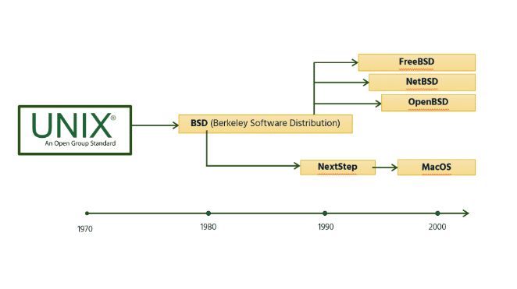
Linux is a Unix-like operating system created by Linus Torvalds in 1991. It is known for its robustness, stability, and flexibility. Linux is a free and open-source operating system and its source code can be modified and distributed to anyone under the GNU General Public License. Modifications of the base Linux code and libraries are referred to as distributions or "distros." Today, there are over 600 Linux distributions and some of the popular ones include:
- Ubuntu
- Debian
- Fedora
- Arch Linux
Benefits

Internet Service Providers, network operators, universities, banks, and many large enterprises use Unix/Linux servers to provide key services to their customers or communities. Knowledge of the benefits offered by these operating systems is an important skill for upcoming network and system engineers.

Some key benefits include lower costs, command-line products, and stability and scalability.
Lower startup costs: Unix and Linux software can be implemented and run at a lower cost than proprietary solutions, resulting in practically zero license costs in some cases. For tech entrepreneurs, this means lower startup costs.
Command-line products: Network vendor routers and switches often use command-line interfaces, often based on Unix or Linux.
Stability and scalability: Unix and Linux solutions power many Internet services like email, web, and DNS servers, demonstrating their stability and scalability.
Unix-Linux Benefits
Internet Service Providers, Network Operators, Universities, banks, and many large enterprises use UNIX/Linux servers to provide key services to their customers or communities.
Knowledge of the benefits offered by these operating systems is an important skill for upcoming network and system engineers
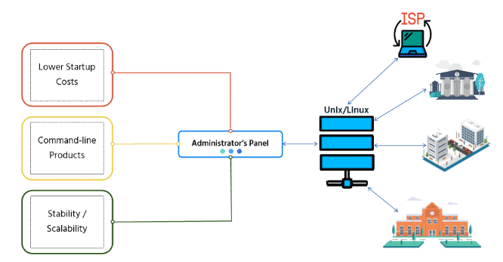
Some key benefits include:

- Lower startup costs - Unix and Linux software can be implemented and run at a lower cost than proprietary solutions, resulting in practically zero license costs in some cases. For tech entrepreneurs, this means lower startup costs.
- Command-line products - Network vendor routers and switches often use command-line interfaces, often based on Unix or Linux.
- Stability and Scalability - Unixand Linux solutions power many Internet services like email, web, and DNS servers, demonstrating their stability and scalability.

